NBL 356 Module 5 Review Q&A

(Note this review document is derived directly from content in Wikipedia and Lumen articles with some condensing and editing.)

*1. Somatosensory tracts (axons from secondary sensory neurons) ascend to and synapse on neurons in which major region of the thalamus? What are the two specific nuclei/regions of this, and which one receives information from the body and which receives information from the head and face?*

Secondary sensory axons (that transmit somatosensory information) travels to and synapse on neurons in the ventral posterior nucleus (VPN) of the thalamus. The two specific regions in the thalamus VPN that relay somatosensory information are the ventral posterior lateral (VPL) nucleus, which receives and relays information from the body and the ventral posterior medial (VPM) nucleus receives and relays information from the head and face. Neurons in both areas of the VPN transmit somatosensory information to the primary somatosensory cortex (and some other areas).

*2. Neurons in the thalamus project to both the somatosensory cortex and other cortical regions. Describe the flow of somatosensory information from the thalamus.*

Somatosensory information is transmitted from the VPN of the thalamus to S1 where it is integrated, then to S2, which is involved in perception, and to the posterior parietal cortex, which is involved in integration of somatosensory information with visual and auditory information, and is transmitted to the motor cortex (and other areas). S2 also sends information to the amygdala and hippocampus for emotional and memory processing.

For pain processing, information is transmitted directly from the thalamus to S1, S2, the insula, and anterior cingulate cortex. As describe above, pain information is also transmitted from the spinal cord secondary somatosensory neurons to nuclei in the brainstem (including the periaqueductal gray (nucleus) and parabrachial nuclei), which transmit pain information directly to the amygdala and hippocampus.

*3. Describe the somatotopic map in the primary somatosensory cortex. How was it mapped? How does this compare with the somatotopic map in the primary motor cortex? What cortical regions and subregions comprise the primary somatosensory cortex (S1) and what types of information go to which area? What is S2? How does information flow to and within the somatosensory cortex (S1 and S2)? What does it mean that there is both serial and parallel information processing in the primary somatosensory cortex?*

The somatotopic map in S1 (in the postcentral gyrus) is similar to the motor map in the motor cortex (M1 and premotor cortex), which is located across the central sulcus in the precentral gyrus. S1 and M1 were mapped by Dr. Penfield, using electrical stimulations and recordings in wake humans during brain surgery. SI includes Brodmann areas 3a, 3b, 1 and 2. Area 3a receives and processes proprioceptive information. Area 3b receives and processes touch, pain and temperature information. In serial processing, information is transmitted from Are 3b or 3a, to Area 1 to Area 2, then to S2 (SII = secondary somatosensory cortex) and to area 5/7 (the posterior parietal cortex). S1 also provides information directly to motor cortex. In parallel processing, information is sent independently and simultaneously from the thalamus to 3a/3b, and area 1 and area 2.

Review From Wikipedia: Somatosensory cortex

BA3 receives the densest projections from the thalamus. BA3a is involved with the sense of relative position of neighboring body parts and amount of effort being used during movement. BA3b is responsible for distributing somatosensory information, it projects texture information to BA1 and shape and size information to BA2.

Region S2 (secondary somatosensory cortex) divides into Area S2 and parietal ventral area. Area S2 is involved with specific touch perception and is thus integrally linked with the amygdala and hippocampus to encode and reinforce memories.

Parietal ventral area is the somatosensory relay to the premotor cortex and somatosensory memory hub, BA5. BA5 is the topographically organized somato memory field and association area. BA1 processes texture info while BA2 processes size + shape info. Area S2 processes light touch, pain, visceral sensation, and tactile attention. S1 processes the remaining info (crude touch, pain, temperature). BA7 integrates visual and proprioceptive info to locate objects in space. The insular cortex (insula) plays a role in the sense of bodily-ownership, bodily self-awareness, and perception. Insula also plays a role in conveying info about sensual touch, pain, temperature, itch, and local oxygen status. Insula is a highly connected relay and thus is involved in numerous functions.

Secondary Cortical Receiving Area (From <https://nba.uth.tmc.edu/neuroscience/m/s2/chapter05.html> and see Lecture 2 Slide 7)

The secondary somatosensory cortex, SII, is located inferiorly - in the pars opercularis of the parietal lobe, which forms part of upper lip of the lateral sulcus. SII neurons send their axons to SI, association cortex, motor cortex, and insula. The latter projection, to the insula, influences structures such as the amygdala and hippocampus. These structures are important in tactile learning and memory. The projection to the somatosensory association cortex is involved in higher order processing required for recognizing hand-held objects by texture and size. Consequently, lesions in SII produce deficits in learning by object manipulation and in recognizing the texture and size of hand-held objects.

Association Cortical Area

The somatosensory association cortex is located in the superior parietal lobe (a.k.a. posterior parietal cortex), which is posterior to SI. The highest degree of convergence of somatosensory information occurs in the posterior parietal cortex. The posterior parietal cortex receives the axons of SI and SII neurons and also receives input from the visual system and other systems involved in attention and motivation.

Neurons in the posterior parietal cortex are responsive to somatosensory and visual stimuli, have large somatic receptive fields in which responsiveness is based on stimulus context, and are often more responsive to stimulus movement.

Large lesions involving the posterior parietal cortex and the adjoining superior temporal gyrus may result in an attentional deficit called “neglect”, wherein there is a partial neglect (inattention) to tactile, proprioceptive and/or visual stimuli delivered contralateral to the lesion site. The patient is described as ignoring the contralesional half of her/his body and space. The perception of a "whole" body is lost and the body parts affected may be considered to belong to someone else. Visual stimuli on the contralesional side may also be ignored.

Cortical Areas for Pain Sensation

Pain information is processed in multiple pathways (see Table 1 in the chapter on Somatosensory Systems) involving multiple thalamic nuclei that project to multiple cortical areas. In addition to the somatosensory cortex, painful stimuli activate neurons in the rostral cingulate gyrus and the insula. Consequently, all pain sensation is not lost when the primary somatosensory cortex is damaged. Primary somatosensory cortex neurons that have small receptive fields and are selectively responsive to sharp, cutting painful stimuli are considered to provide the ability to accurately localize the exact point of contact with the painful stimulus. Lesions of the primary somatosensory cortex will affect the quality of pain sensations and the ability to localize the exact location of the painful stimulus

*4. Describe the descending pain pathways. How could antidepressants modulate chronic pain?*

From several web sites: “Just as there are ascending pain pathways from the body to the brain, there are also descending pain pathways communicating from the brain to the body which inhibit pain. The most important descending pathways begin in the periaqueductal gray (PAG). Stimulation of the PAG has been shown to produce analgesia, but no change in the ability to detect temperature, pressure, or touch. The neurons beginning in the PAG end on cells in the medulla, including the serotonergic cell bodies of the raphe nuclei. The serotonergic neurons then descend into the spinal cord to inhibit cell firing. Other cells in the PAG terminate close to the locus coeruleus (that release norepinephrine) in the brainstem. Thus, there are at least two major pathways that descend to the spinal cord to inhibit the projection of pain.” In the dorsal horn, the release of serotonin and norepinephrine leads to a reduction of the transmission of pain information by nociceptors to secondary sensory neurons. It may involve effects of serotonin and norepinephrine on inhibitory spinal interneurons to release endogenous opioid peptide such as encephalin that reduce transmission from the nociceptor to its secondary sensory neuron. It has also been proposed that the effects of serotonin and norepinephrine may be direct at inhibition of transmission from the nociceptor to the secondary sensory neuron. “At the spinal level, opiate receptors are located at the presynaptic ends of the nociceptors and at the interneural level layers IV to VII in the dorsal horn. Activation of opiate receptors at the interneuronal level produces hyperpolarization of the neurons, which result in the inhibition of firing and the release of substance P, a neurotransmitter involved in pain transmission, thereby blocking pain transmission.” Inhibitory GABAergic interneurons in the PAG also express endogenous opioid receptors. When these are activated, this reduces the activity of the GABAergic inhibitory interneurons, so there is less inhibition and this increases the output from the PAG neurons that activate the descending pathways to the Raphe nucleus and locus coeruleus to release serotonin and norepinephrine respectively.

Many antidepressants, including the tricyclic antidepressants, selective serotonin reuptake inhibitors (SSRIs), serotonin–norepinephrine reuptake inhibitors (SNRIs) and norepinephrine reuptake inhibitors (NRIs), work by inhibiting reuptake of monoamines, including serotonin, dopamine and/or norepinephrine. If the descending pain pathways involve the monoamines serotonin and norepinephrine as described, which inhibit pain transmission, then increasing those monoamine levels by blocking reuptake using antidepressants, could have an additional effect to decrease pain transmission.

*5. What is referred pain?*

From Wikipedia: “Referred pain, also called reflective pain, is pain perc eived at a location other than the site of the painful stimulus. An example is the case of angina pectoris brought on by a myocardial infarction (heart attack), where pain is often felt in the neck, shoulders, and back rather than in the thorax (chest), the site of the injury. The International Association for the Study of Pain has not officially defined the term; hence several authors have defined it differently. Radiating pain is slightly different from referred pain; for example, the pain related to a myocardial infarction could either be referred or radiating pain from the chest. Referred pain is when the pain is located away from or adjacent to the organ involved; for instance, when a person has pain only in their jaw or left arm, but not in the chest. Referred pain has been described since the late 1880s. Despite an increasing amount of literature on the subject, the biological mechanism of referred pain is unknown, although there are several hypotheses.” One hypothesis is that the visceral sensory neurons (that for example innervate the heart) synapse on and converge on the same secondary sensory neurons in the dorsal horn that transmit somatosensory pain-nociceptor information from the dermatome.

6. What is olfaction?

Olfaction is the sensation that forms the sense of smell. The olfactory system, is the sensory system used for smelling (olfaction). Olfaction is one of the special senses, which have directly associated specific organs. Most mammals have a main olfactory system and an accessory olfactory system. The main olfactory system detects airborne substances (called odor molecules or odorants), while the accessory system senses fluid-phase stimuli. The senses of smell and taste (gustatory system) are often referred to together as the chemosensory system, because they both give the brain information about the chemical composition of stimuli through a process called transduction. Olfaction integrates with other senses to form the sensory impression of food called flavor. Submodalities of smell are not well defined but odors can be classified as either pleasant or offensive, and into categories such as fragrant/floral, fruity, citrus, grassy, herbal, sweet, minty, nutty, pungent, rancid or decayed/rotten.

7. What are the receptor cells and stimulus involved in smell?

Odorants, which are chemicals, are the stimulus modality and the receptors are called olfactory receptor cells (also called olfactory sensory neurons). Olfactory receptor cells are the only type of special sense neurons that contain both sensory dendritic endings and an axon, so they produce action potentials. (In other special senses, photoreceptor cells, taste cells and hair cells in hearing and balance are neurons but do not have axons but through synaptic transmission depend on downstream neurons to transmit the sensory information through action potentials to the brain.) Moreover, olfactory neurons are the one type of neuron that routinely regenerate from progenitor cells throughout life. To reduce the risk of olfactory neurons being harmed by inhaled toxins, they have a limited lifespan of about 60 days. Because of this imposed cell death, stem/progenitor cells within the nasal epithelial layer differentiate into new olfactory neurons.

8. Where are the receptor cells located?

The nasal cavity is divided into two segments: the respiratory segment, containing the respiratory epithelium which is not innervated, and the olfactory segment containing the olfactory epithelium which is innervated. In vertebrates, smells are sensed by olfactory sensory neurons in the olfactory epithelium located on the roof of the nasal cavity. The olfactory epithelium is composed of several different cell types. The proportion of olfactory epithelium compared to respiratory epithelium reflects the animal's olfactory sensitivity.

9. How do odorants gain access to receptor cells?

Chemicals/molecules of odorants passing through the superior nasal concha of the nasal passages dissolve in the mucus that lines the superior portion of the cavity and are detected by olfactory receptors on the sensory dendritic endings of the olfactory sensory neurons. This may occur by diffusion or by the binding of the odorant to odorant-binding proteins that help keep them dissolved in the mucus and transport them to the olfactory dendrites. This mucus acts as a solvent for odor molecules, flows constantly, and is replaced approximately every ten minutes.

10. How are odorants detected (what is the molecular receptor) and what is the mechanism of olfactory sensory transduction?

Odorant receptors are types of G protein coupled receptor. There are about 1000 different odorant receptor genes making it the largest receptor gene family. Binding of the ligand (odor molecule or odorant) to the receptor leads to an action potential in the olfactory receptor neuron, via a second messenger pathway. In mammals, the odorants stimulate the enzyme adenylate (adenylyl) cyclase to synthesize cAMP via activation of the G protein called Golf. cAMP, which is the second messenger here, opens a cyclic nucleotide-gated ion channel (CNG), producing an influx of cations (largely Ca2+ with some Na+) into the receptor cell, slightly depolarizing it. The Ca2+ in turn opens a Ca2+-activated chloride channel, leading to efflux of Cl−, further depolarizing the cell and triggering an action potential. After stimulation, Ca2+ is then extruded through a sodium-calcium exchanger and calcium ATPase pumps. A calcium-calmodulin complex also acts to inhibit the binding of cAMP to the cAMP-dependent channel, thus contributing to olfactory adaptation.

Note that olfactory transduction is somewhat similar to the transduction mechanism for photoreceptors but with an important difference. In photoreceptors in the dark, high levels of the second messenger cGMP leads to the persistent opening of cGMP gated channels. The stimulus light produces to a decrease in the cGMP levels (by activation of PDE) which leads to closing of the cGMP gated channels, hyperpolarization of the membrane potential and a decrease in the release of its neurotransmitter glutamate.

11. Once the action potential is produced in the olfactory receptor neuron, what happens next?

Olfactory sensory neurons project axons forming the olfactory nerve (cranial nerve I) to the olfactory bulb in the brain. These unmyelinated axons (in CNI) travel to the olfactory bulb of the brain through perforations in the cribriform plate of the ethmoid bone. The axons from the olfactory receptors converge in the outer layer of the olfactory bulb within small structures called glomeruli. The glomerulus (plural glomeruli) is a spherical structure located near the surface of the olfactory bulb where synapses form between the terminals of the olfactory receptor axons and the dendrites of neurons called mitral, periglomerular and tufted cells. The mitral cell bodies and tufted cell bodies are located outside the glomeruli and their axons are the main outputs from the olfactory bulb, sending the information about the odor to other parts of the olfactory system. (Many figures show axonal output from only mitral cells in the olfactory bulb.)

The olfactory receptor neurons, which originate in the nasal epithelium express only one type of odorant receptor. As described, olfactory receptor neurons project their axons to the olfactory bulb. In the olfactory bulb, the olfactory receptor axons synapse with dendrites in the glomeruli. Each glomerulus receives input from olfactory receptor neurons expressing only one type of olfactory receptor. A large degree of convergence occurs, with ~25,000 axons synapsing on 25 or so mitral cells; each mitral cell can project dendrites to multiple glomeruli. Mitral cells also receive information from periglomerular cells and granular cells that inhibit the mitral cells surrounding it (lateral inhibition).

12. What are the outputs from the olfactory bulb?

The mitral cell axons and tufted cell axons leave the olfactory bulb in the lateral olfactory tract. Mitral cell axons synapse on major regions of the cerebrum: the anterior olfactory nucleus, the olfactory tubercle, the piriform cortex, the entorhinal cortex, and periamygdaloid cortex. Together these cortical areas form the “olfactory cortex.” Axons from mitral cells also project directly to the amygdala (also called the amygdaloid complex) and hypothalamus. Tufted cells project mainly to the anterior olfactory nucleus.

The piriform cortex projects to the medial dorsal nucleus of the thalamus, which then projects to the orbitofrontal cortex. The orbitofrontal cortex mediates conscious perception of the odor. The entorhinal cortex projects to the amygdala (and there is direct input to the amygdala) and both are involved in emotional and autonomic responses to odor. The entorhinal cortex also projects to the hippocampus and is involved in motivation and memory. Odor information is stored in long-term memory and has strong connections to emotional memory. This is possibly due to the olfactory system's close anatomical ties to the limbic system and hippocampus, areas of the brain that have long been known to be involved in emotion and place memory, respectively. The hypothalamus projects to the reticular formation and odors can also trigger visceral reflexes through this connection to the brainstem.

It has been shown that each individual odor gives a particular spatial map of excitation in the olfactory bulb. It is possible that the brain is able to distinguish specific odors through spatial encoding, but temporal coding must also be taken into account. Over time, the spatial maps change, even for one particular odor, and the brain must be able to process these details as well.

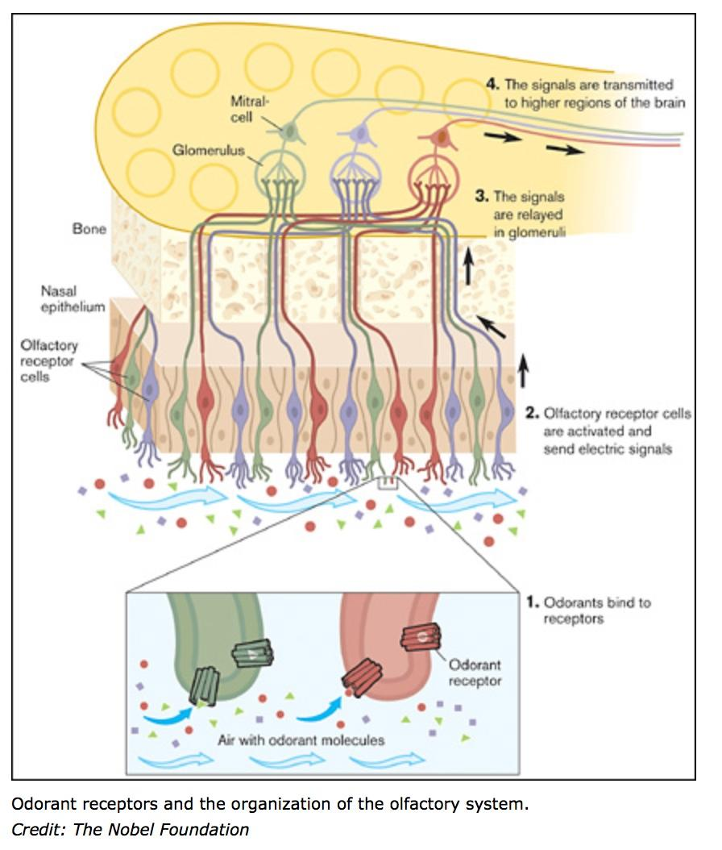 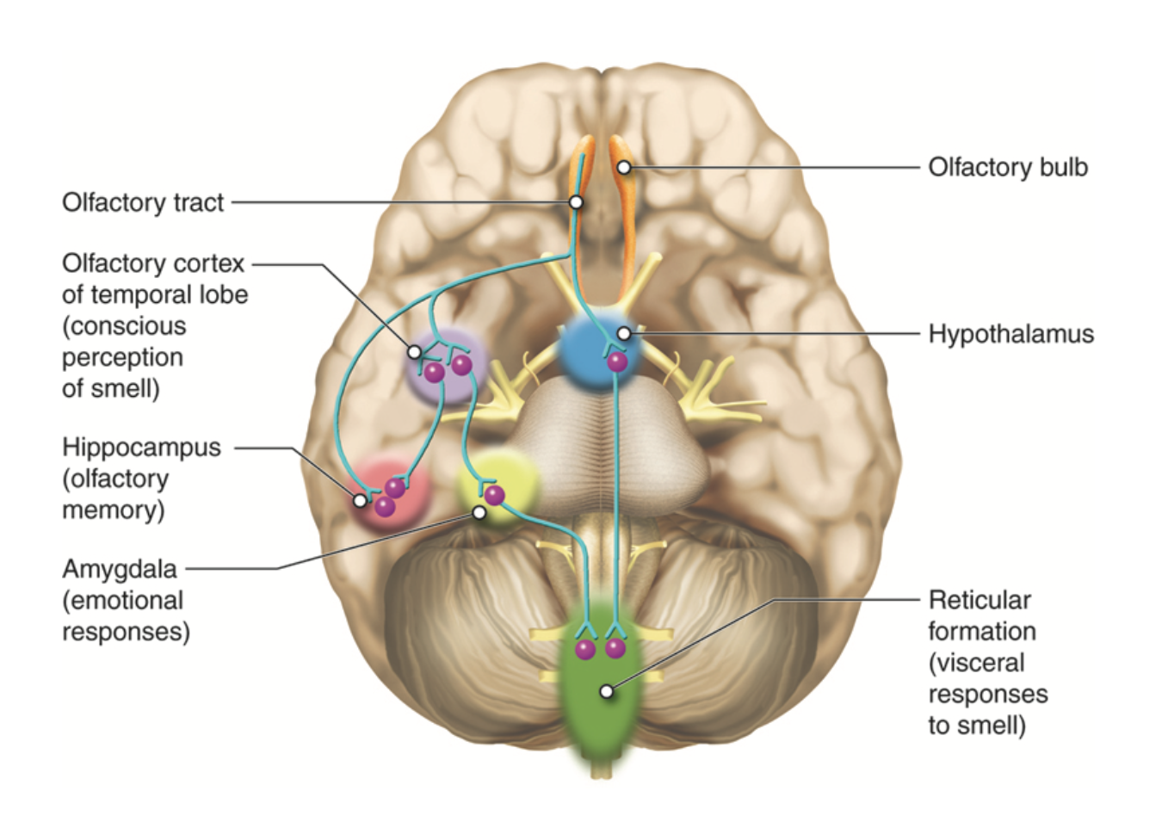 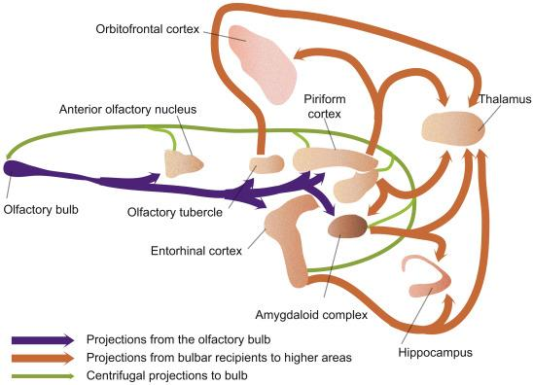

13. What is gustation (taste)?

Taste is the sensation produced when a chemical in the mouth activates taste receptor cells located on taste buds in the oral cavity, mostly on the tongue. The sensation of taste includes five established basic distinct taste submodalities: sweetness, sourness, saltiness, bitterness, and umami. Taste in the gustatory system allows humans to distinguish between safe and harmful food, and to gauge foods’ nutritional value. As taste senses both harmful and beneficial things, all basic tastes are classified as either aversive or appetitive, depending upon the effect the things they sense have on our bodies. Sweetness helps to identify energy-rich foods, while bitterness serves as a warning sign of poisons. Together with olfaction, gustation is one of the “chemical senses.”

14. What are the receptor cells and stimulus involved in taste and where are they located?

Digestive enzymes in saliva begin to dissolve food into chemicals (tastants) that are washed over the papillae and detected as tastes by the taste buds. The tongue is covered with thousands of small bumps called papillae, which are visible to the naked eye. Within each papilla are hundreds of taste buds. The exception to this are the filiform papillae that do not contain taste buds. There are between 2000 and 5000 taste buds that are located on the back and front of the tongue. Others are located on the roof, sides and back of the mouth, and in the throat. Each taste bud contains 50 to 100 taste receptor cells.

The primary organ of taste is the taste bud. A taste bud is a cluster of gustatory receptors (taste cells) that are located within the bumps on the tongue called papillae (singular: papilla). There are several structurally-distinct papillae. Filiform papillae, which are located across the tongue, are tactile, providing friction that helps the tongue move substances; they contain no taste cells. In contrast, fungiform papillae, which are located mainly on the anterior two-thirds of the tongue, each contain one to eight taste buds; they also have receptors for pressure and temperature. The large circumvallate papillae contain up to 100 taste buds and form a V near the posterior margin of the tongue.

15. How are tastants detected (what is the molecular receptor) and what is the mechanism of gustatory sensory transduction?

In humans, there are five primary tastes; each taste has only one corresponding type of receptor. Thus, like olfaction, each receptor is specific to its stimulus (tastants). Transduction of the five tastes happens through different mechanisms that reflect the molecular composition of the tastant. A salty tastant (containing NaCl) provides the sodium ions (Na+) that enter the taste neurons, exciting them directly. Sour tastants are acids, which activate receptors that are members of thermoreceptor protein family. Binding of an acid or other sour-tasting molecule triggers a change in the ion channel, which increases hydrogen ion (H+) concentrations in the taste neurons; thus, depolarizing them. Sweet, bitter, and umami tastants require a G-protein-coupled receptor. These tastants bind to their respective receptors, thereby exciting the specialized neurons associated with them.

Sour: Sourness is the taste that detects acidity. Sour taste is detected by a small subset of cells that are distributed across all taste buds in the tongue. There is evidence that the protons that are abundant in sour substances can directly enter the sour taste cells through plasma membrane ion channels (for H+ or proton). The proton selective ion channel otopetrin 1 (Otop1) was implicated as the primary mediator of this proton influx. The influx of positive charge into the cell leads to depolarization of the membrane potential. For weak acids, the intracellular hydrogen ions inhibit potassium channels, which normally function to hyperpolarize the cell. By a combination of direct intake of hydrogen ions (which itself depolarizes the cell) and the inhibition of the hyperpolarizing K+ channels, sourness causes the taste cell to depolarize and release neurotransmitter.

Salty: The simplest receptor found in the mouth is the sodium chloride (salt) receptor. Saltiness is a taste produced primarily by the presence of sodium ions. Other ions of the alkali metals group also taste salty. A sodium channel in the taste cell wall allows sodium cations to enter the cell. This on its own depolarizes the cell, and opens voltage-dependent calcium channels, leading to neurotransmitter release. This sodium channel is known as an epithelial sodium channel (ENaC).

Bitter: Bitterness is one of the most sensitive of the tastes, and many perceive it as unpleasant, sharp, or disagreeable, but it is sometimes desirable and intentionally added.

The ability to detect bitter-tasting, toxic compounds at low thresholds is considered to provide an important protective function. Research has shown that TAS2Rs (taste receptors, type 2, also known as T2Rs) such as TAS2R38 coupled to the G protein gustducin are responsible for the human ability to taste bitter substances. The TAS2R family in humans is thought to comprise about 25 different taste receptors. The G protein activated by gustducin activates phosphodiesterase (PDE), which hydrolyzes the second messengers cAMP & cGMP. When cAMP/cGMP is decreased, this closes a K+ channel. Also, this secondary messenger can stimulate the endoplasmic reticulum to release Ca2+, which contributes to depolarization. This leads to an increase of potassium ions in the cell, depolarization, and neurotransmitter release.

Sweet: Sweetness is often connected to aldehydes and ketones, which contain a carbonyl group. Sweetness is detected by a variety of G protein coupled receptors coupled to the G protein gustducin found on the taste buds. At least two different variants of the "sweetness receptors" must be activated for the brain to register sweetness. “Natural” sweeteners such as saccharides activate the GPCR, which activates gustducin. The gustducin then activates the molecule adenylyl cyclase, which catalyzes the production of the second messenger cAMP. The cAMP closes potassium ion channels, leading to depolarization and neurotransmitter release.

Savory/Umami: Savory is an appetitive taste and is occasionally described by its Japanese name, umami or "meaty". The tastants has been identified as the chemical monosodium glutamate (MSG). Some savory taste buds respond specifically to glutamate in the same way that "sweet" ones respond to sugar. Glutamate binds to a variant of G protein coupled glutamate receptors. L-glutamate may bond to a type of GPCR known as a metabotropic glutamate receptor (mGluR4), which causes the G-protein complex to activate the sensation of umami.

Recent research reveals a potential taste receptor called the CD36 receptor, which is a possible lipid taste receptor because it binds to fat molecules (more specifically, long-chain fatty acids),

16. Taste receptor cells do not contain axons or produce action potentials. How and to where is the taste signal transmitted to the brain?

Once the taste cells are activated by tastants, they release neurotransmitters onto the dendrites of adjacent sensory neurons. The different taste bud cells secrete different neurotransmitters, including ATP, acetylcholine, serotonin, norepinephrine and/or GABA. The neurotransmitters bind to receptors on the dendrites of sensory neurons, which are similar in morphology to somatosensory neurons, with their cell bodies located in specific sensory ganglia located outside the brainstem. The axons of these sensory neurons form parts of the facial (CNVII) and glossopharyngeal (CNIX) cranial nerves, as well as a component within the vagus nerve (CNX) dedicated to the gag reflex. The facial nerve connects to taste buds in the anterior third of the tongue. The glossopharyngeal nerve connects to taste buds in the posterior two thirds of the tongue. The vagus nerve connects to taste buds in the extreme posterior of the tongue, verging on the pharynx. Axons from these three cranial nerves carrying taste information to the medulla. The region of the medulla that receives taste information is called the nucleus of the solitary tract (nucleus tractus solitarius). From there much of the information is transmitted to the thalamus (the ventral posterior medial nucleus) and then routed to the primary gustatory cortex, located near the inferior margin of the post-central gyrus. It is the primary gustatory cortex that is responsible for our sensations of taste. It consists of two substructures: the anterior insula on the insular lobe and the frontal operculum on the inferior frontal gyrus of the frontal lobe. And, although these regions receive significant input from taste buds, it is likely that it also receives information about the smell and texture of food, all contributing to our overall taste experience. The orbitofrontal cortex is the taste association area. The nuclei in the medulla also send projections to the hypothalamus and amygdalae, which are involved in autonomic reflexes such as gagging and salivation.

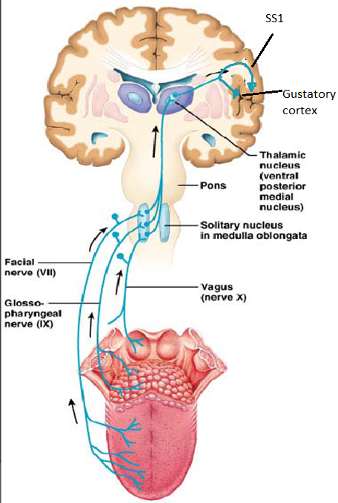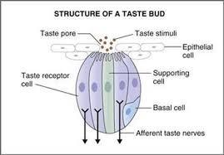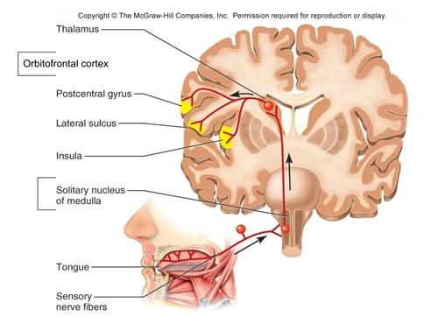

17. What is audition (hearing)?

Hearing, or auditory perception, is the ability to perceive sounds by detecting vibrations, (changes in the pressure of the surrounding medium through time), in humans using specialized cells in the ear. Our auditory system converts pressure waves into meaningful sounds. In humans and other vertebrates, hearing is performed primarily by the auditory system: mechanical waves, known as vibrations, are detected by the ear and transduced into nerve impulses that are perceived by the brain (primarily in the temporal lobe). Like touch, audition requires sensitivity to the movement of molecules in the world outside the organism. Both hearing and touch are types of mechanosensation.

18. What are the receptor cells and stimulus involved in hearing?

There are three main components of the human auditory system: the outer ear, the middle ear, and the inner ear. The outer ear includes the pinna, which is the visible part of the ear that protrudes from our heads, the auditory canal, and the tympanic membrane, or eardrum. The middle ear contains three tiny bones known as the ossicles, which are named the malleus (or hammer), incus (or anvil), and the stapes (or stirrup). The inner ear contains the semi-circular canals, which are involved in balance and movement (the vestibular sense), and the cochlea. The cochlea is a fluid-filled, snail-shaped structure that contains the sensory receptor cells (hair cells) of the auditory system.

Here is a more detailed description of the ear anatomy and physiology for clarity but these details will not be on the quiz or exam: The outer ear includes the pinna, the visible part of the ear, as well as the ear canal which terminates at the eardrum, also called the tympanic membrane. The pinna serves to focus sound waves through the ear canal toward the eardrum. This gives these animals the ability to localize sound vertically. The eardrum is an airtight membrane, and when sound waves arrive there, they cause it to vibrate following the waveform of the sound.

The middle ear consists of a small air-filled chamber that is located medial to the eardrum. Within this chamber are the three smallest bones in the body, known collectively as the ossicles, which include the malleus, incus, and stapes (also known as the hammer, anvil, and stirrup, respectively). They aid in the transmission of the vibrations from the eardrum into the inner ear, the cochlea. Also located in the middle ear are the stapedius muscle and tensor tympani muscle, which protect the hearing mechanism through a stiffening reflex. The stapes transmits sound waves to the inner ear through the oval window, a flexible membrane separating the air-filled middle ear from the fluid-filled inner ear. The round window, another flexible membrane, allows for the smooth displacement of the inner ear fluid caused by the entering sound waves

The inner ear consists of the cochlea, which is a spiral-shaped, fluid-filled tube. It is divided lengthwise by the organ of Corti, which is the main organ of mechanical to neural transduction. Inside the organ of Corti is the basilar membrane, a structure that vibrates when waves from the middle ear propagate through the cochlear fluid – endolymph. The basilar membrane is tonotopic, so that each frequency has a characteristic place of resonance along it. Characteristic frequencies are high at the basal entrance to the cochlea, and low at the apex.

19. How is sound detected (what is the molecular receptor) and what is the mechanism of auditory sensory transduction?

The vibration of the tympanic membrane is what triggers the sequence of events that lead to our perception of sound. Sound waves travel into our ears at various speeds and amplitudes. The frequency of a sound wave is associated with our perception of that sound’s pitch. High-frequency sound waves are perceived as high-pitched sounds, while low-frequency sound waves are perceived as low-pitched sounds. The motion of the basilar membrane causes depolarization of the hair cells, the specialized auditory receptor cells located within the organ of Corti.

Sound waves travel along the auditory canal and strike the tympanic membrane, causing it to vibrate. This vibration results in movement of the three ossicles. As the ossicles move, the stapes presses into a thin membrane of the cochlea known as the oval window. As the stapes presses into the oval window, the fluid inside the cochlea begins to move, which in turn stimulates hair cells, which are auditory receptor cells of the inner ear embedded in the basilar membrane. The basilar membrane is a thin strip of tissue within the cochlea. Sitting on the basilar membrane is the organ of Corti, which runs the entire length of the basilar membrane from the base (by the oval window) to the apex (the “tip” of the spiral). The organ of Corti includes three rows of outer hair cells and one row of inner hair cells. The hair cells sense the vibrations by way of their tiny hairs, or actin-filled stereocilia. The mechanically sensitive organelle of the hair cell is the hair bundle, a cluster of ~100 hair cells. Hair cells respond to deflections of their hair bundles by opening transduction channels. The fluid, termed endolymph, which surrounds the hair cells, is rich in K+. When the cilia are bent toward the tallest one by the wave, the mechanosensitive channels are opened. Opening these channels allows an influx of K+, which depolarizes the membrane potential and opens the voltage gated Ca2+ channels that initiates neurotransmitter release.

Several mechanosensitive channels have been identified, including MET, PIEZO and several others. Because transduction channels are cation selective and because hair cells sit at a resting potential of about −60 mV, channel opening induces an inward current. Since the endolymph contains high K+, an inward K+ current depolarizes the cell. When all transduction channels open, their total conductance dominates other ion channels and the cell depolarizes toward ~0 mV, and opens voltage-dependent Ca2+ channels. Depolarization activates neurotransmitter release at the base of the hair cell. The hair cells are glutamatergic neurons.

20. How is sound information transmitted to the brain?

The auditory hair cells do not produce action potentials themselves, but they release neurotransmitter (glutamate) at synapses on sensory neurons whose axons form the auditory nerve, which do produce action potentials. These sensory neurons are similar in morphology to somatosensory neurons. The auditory nerve is a part of the vestibulocochlear nerve (CN VIII). The patterns of oscillations on the basilar membrane are converted to spatiotemporal patterns of action potential firings, which transmit information about the sound to the brainstem.

The outer hair cells seem to function to mechanically amplify the sound-induced vibrations, whereas the inner hair cells form synapses with the sensory neurons that form the auditory nerve and transduce those vibrations into action potentials, or neural spikes, which are transmitted along the auditory nerve. Axons from the cochlear nerve bifurcate and information is sent to the cochlear nuclei on each side of the brainstem. Axons ascending from both cochlear nuclei synapse in the inferior colliculus, in the midbrain tectum of the brainstem. The inferior colliculus integrates auditory input with limited input from other parts of the brain and is involved in subconscious reflexes such as the auditory startle response. Some axons from cochlear nuclei also synapse on the superior olivary nucleus, which also transmits information to the inferior colliculus.

The inferior colliculus in turn projects to the medial geniculate nucleus (MGN), a part of the thalamus where sound information is relayed to the primary auditory cortex in the temporal lobe. Sound is believed to first become consciously experienced at the primary auditory cortex. Around the primary auditory cortex lies Wernicke’s area, a cortical area involved in interpreting sounds that are necessary to understand spoken words. Like the visual system, there is also evidence suggesting that information about auditory recognition and localization is processed in parallel streams.

The loudness of a given sound is closely associated with the amplitude of the sound wave. Higher amplitudes are associated with louder sounds. Although wave amplitude is generally associated with loudness, there is some interaction between frequency and amplitude in our perception of loudness within the audible range. Different frequencies of sound waves are associated with differences in our perception of the pitch of those sounds. Low-frequency sounds are lower pitched, and high-frequency sounds are higher pitched. But how does the auditory system differentiate among various pitches? Several theories have been proposed to account for pitch perception. The temporal theory of pitch perception asserts that frequency is coded by the activity level of a sensory neuron. This would mean that a given hair cell would fire action potentials related to the frequency of the sound wave. The place theory of pitch perception suggests that different portions of the basilar membrane are sensitive to sounds of different frequencies. More specifically, the base of the basilar membrane responds best to high frequencies and the tip of the basilar membrane responds best to low frequencies. In reality, both theories explain different aspects of pitch perception. The ability to locate sound in our environments is an important part of hearing. Localizing sound could be considered similar to the way that we perceive depth in our visual fields. Like the monocular and binocular cues that provided information about depth, the auditory system uses both monaural (one-eared) and binaural (two-eared) cues to localize sound.

